Please write an automated test in Java, using a tool such as Webdriver, to carry out the following test.

## **Test case**

· Go to [www.rightmove.co.uk](http://www.rightmove.co.uk/)

· Carry out a “for sale” search

· Select various filters in the drop downs

· Click on “find properties”

· Change the sort order on the search results to “newest listed

· Choose the first (non-featured) property in the list

Steps

Go to [www.righmove.co.uk](http://www.righmove.co.uk)

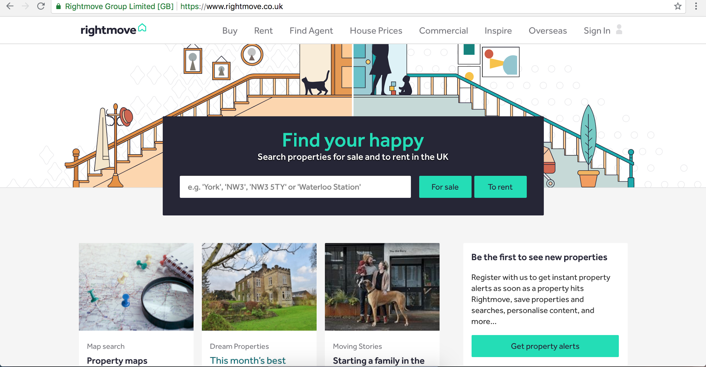

Carry out a “for sale” search

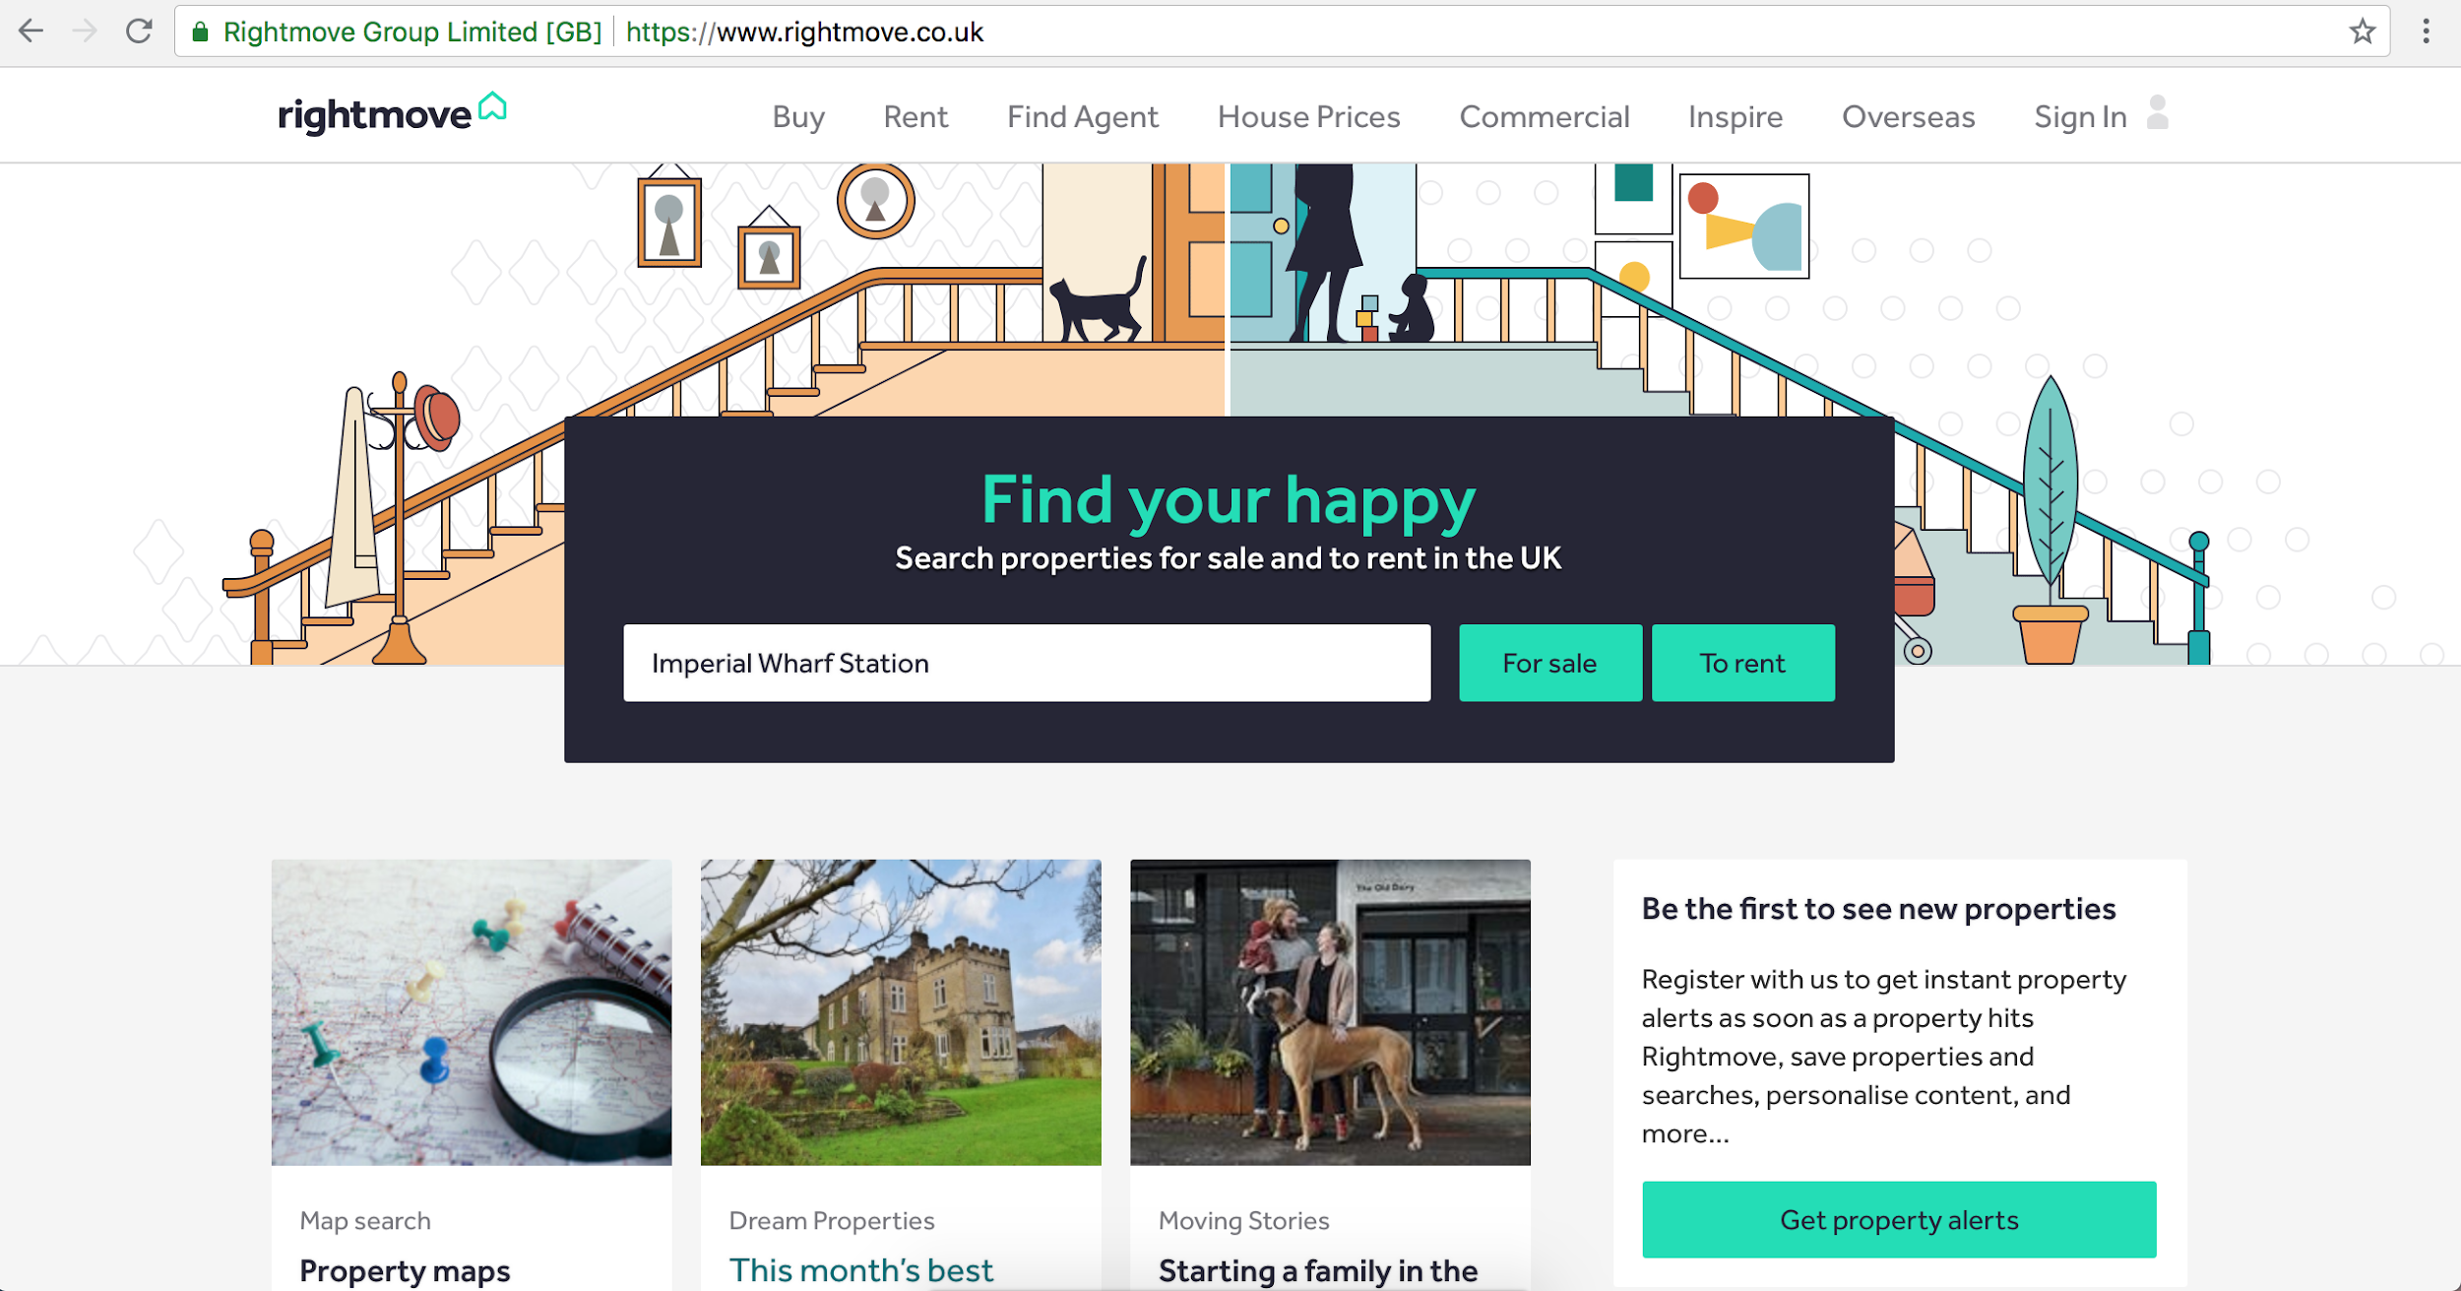

Type Imperial Wharf Station or an area or post code

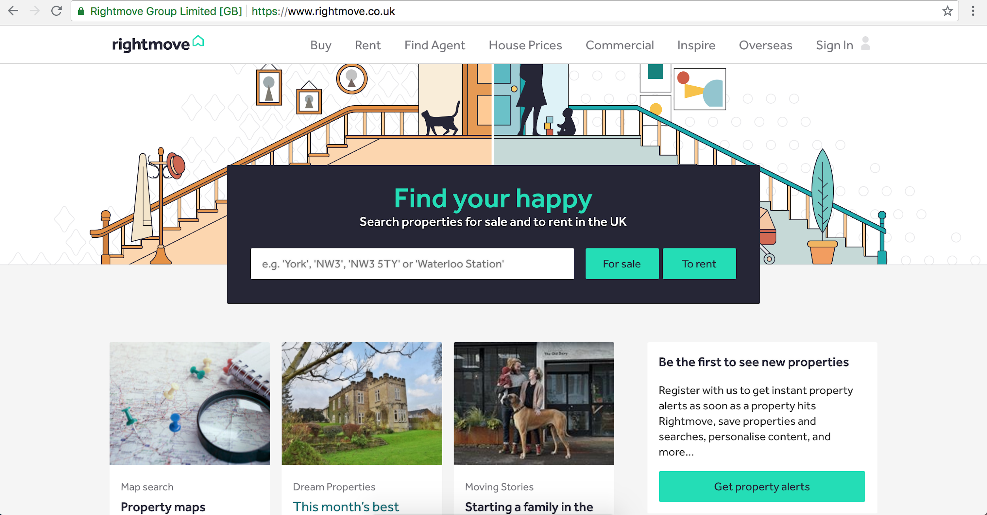

Select various filters in the drop downs

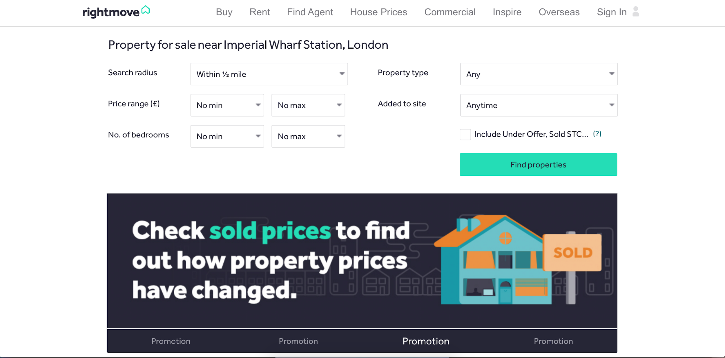

Click find properties button



Change the sort order on the search results to “newest listed

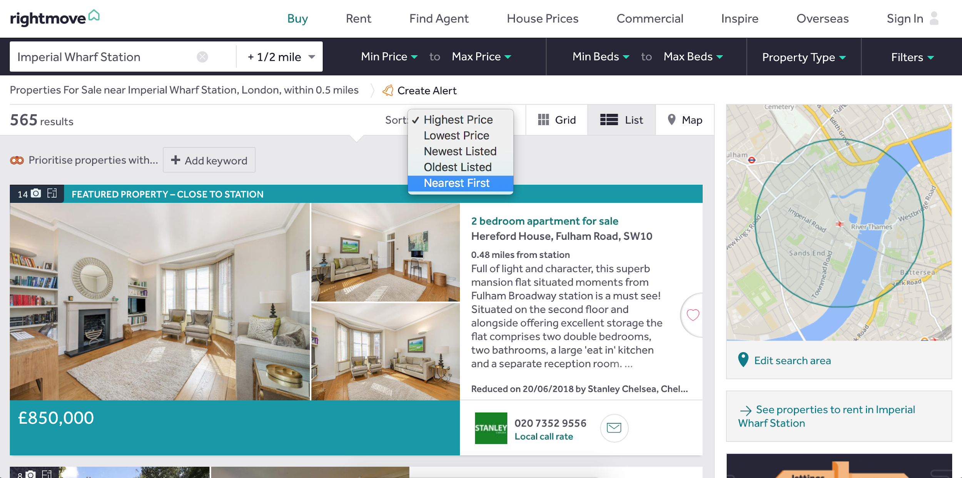

Choose the first (non-featured) property in the list

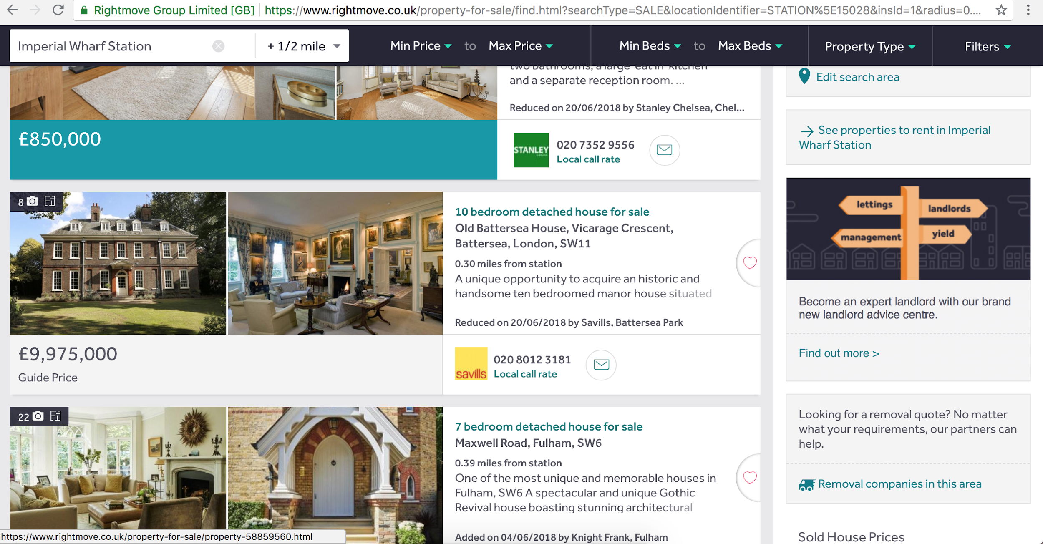



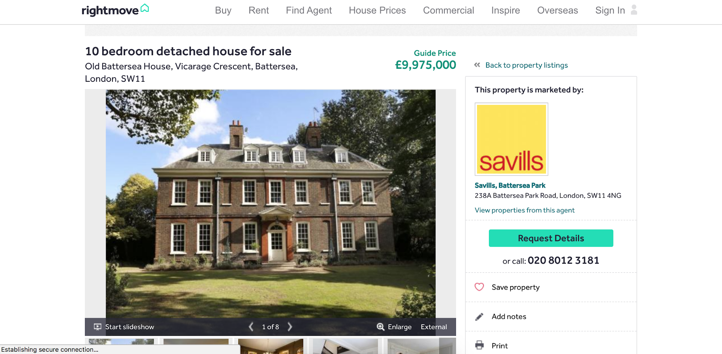

This is a non featured property